Ben Carpenter

James Stevens

Professor Hao Loi

Intro to Software Engineering CSC 212-90

25 April 2025

Generative AI and Learning: Using Retrieval-Augmented Generation (RAG) for C++ Tutoring

**Abstract:**

By utilizing advancements from the field of AI, we aim to develop a tutoring app that answers the questions of intro-level C++ programming students, while creating a framework to expand into other academic areas. A Retrieval-Augmented Generation (RAG) approach will provide targeted feedback, dynamically generating context-specific responses by interfacing with a locally hosted AI.

Our goal is to minimize the risk of oversaturated or hallucinated responses. By processing incoming questions from users and communicating with the AI model, a RAG method ensures that the answers generated by the backend are both concise and relevant to the search. The front end will allow students to easily input their questions and view immediate feedback, ultimately enhancing the interactive learning experience. The functionality will be custom-built, while the graphic design from a previous personal project will be used. Combined, these systems will create a user-friendly application that provides students with clear and direct responses to their specific queries.

Overall, the project aims to create a scalable and efficient tutoring tool. Not only would this tool improve students’ understanding of C++ programming concepts, but it could be integrated into other educational platforms. Unlike the VS Code extension Continue or other similar tools, our project is designed as a two-part web application for easy integration into current LMSs (Learning Management Systems). The desired outcome is an engaging, adaptive, and accessible learning environment that can be extended to additional subjects and environments in the future.

**Paper:**

Our objective for this project is the design and implementation of an Artificial Intelligence based tutor app that effectively addresses beginner-level C++ programming questions for students in the introductory computer science course. We chose C++ as the focus of our app because it is a foundational programming language in the software engineering program. It is important for a beginner to understand the more complex syntax of C++ before they can effectively learn topics such as pointers, memory management, data structures, and algorithms. The building blocks of these data types are laid in an introductory course, but the learning curve for C++ is steeper than higher-level languages, such as Python. These advanced concepts are more tedious and harder to grasp in the beginning, therefore an accurate and effective tutor app will enable a beginning student to absorb the new material more effectively.

The frontend is simply a means of accessing the backend. Written in Hypertext Markup Language, it provides a means of interaction with the function and features of the backend. It is the backend that executes the commands and returns the results.

The backend, implemented in Python, will serve as the engine of the application. It will process incoming questions from users and communicate with the Llama 3.2 model via the REST API, ensuring that the answers generated are both concise and relevant. This design minimizes the risk of oversaturated or generic responses, providing students with clear and direct explanations tailored to their queries.

By using a Retrieval-Augmented Generation approach to providing targeted feedback, our goal is to develop a basic, but effective AI framework that facilitates learning. Instead of relying on a pre-stored database of answers, the system will dynamically generate context-specific responses by interfacing with a local Llama3 AI model through Ollama’s local REST API.

We chose Ollama because… By using Llama3…

Retrieval-Augmented Generation is the cornerstone of our project. It is a generative AI process that combines the power of Large Language Models with a curated supply of information. Retrieval-Augmented Generation supplies the AI with contextual information from a data store that is related to a user query. It then uses this context to inform and guide the generative process, giving the AI a stronger knowledge of the topic at hand. (Lu, Yiu, 2.3) (citing references format?)

This approach also solves many of the outstanding issues that exist with generative AI. One of generative AI’s largest and most well-known flaws is that of hallucination, where the AI fabricates information with no factual basis. In a recent study, the authors found that out of 5000 ChatGPT responses, 19.5% contained hallucinations. (Li et al) Retrieval-Augmented Generation “has been used to improve code generation and summarization, enhance text-to-image generation, and perform more advanced slot filling, among other use cases.” (Can Small Language Models With Retrieval-Augmented Generation Replace Large Language Models). By implementing Retrieval-Augmented Generation, we are able to restrict the data pool, thus limiting the AI’s answers from straying into hallucination and solving the problem of hallucination with the use of our tutor.

LLM/SLM

(*beginning of introduction section)*

The value of our project is in its ability to provide an introductory computer science student with a course-specific learning tool. The app is not intended to replace textbooks or teachers, but to help support currently established methods of education. By focusing on specific material as the basis for our tutor app’s responses, we can add support to the development of problem-solving skills for these students, enabling a stronger knowledge of the material.

Online education already exists, though the online materials traditionally used to learn introductory computer science have their limitations. For example, Python Tutor helps students visualize runtime data structure changes during program execution. Visual Algo helps students visualize algorithms through animation. These are good tools and help provide insight into programming, data structures and, algorithms, but they are not always helpful with introductory topics. The issue is accessibility. Since uninitiated students will often lack an understanding of basic concepts, traditional online resources may not always be effective for them. These tools may not offer the flexibility to offer the best examples early on in a student’s coding education. Some newer students can struggle finding pertinent information without a clear overview of the problem.

By using Retrieval-Augmented Generation, the program will dynamically adjust to each unique question, providing students with a personalized response to each question and empowering them with answers that will help build a broader understanding. Because Retrieval-Augmented Generation is capable of drawing on current class materials, it can also focus in on a course-specific information set. By sourcing information from traditional educational resources, such as a textbook, the tutor remains consistent informationally with classroom materials. This feature allows the app to deliver this information in a more engaging, personal way for each student. By using relevant coding examples, it can offer an efficient method in reaching inexperienced students with supportive information, allowing them to better digest the textbook information.

This app can also help build confidence by approaching the information in an unthreatening way. Eliminating the fear of being judged by a tutor or faculty member, students are free to explore answers to their questions in an effective and comfortable environment. By freely pursuing basic questions, students can build their understanding and confidence to ask more precise questions of an instructor. This serves to lower barriers for new students and facilitate quicker, more stress-free progress and eventual mastery of the basics of C++ programming. As students better understand the material, they are more likely to continue in the degree path. (Li…)

*(beginning of related works section)*

This is significant, because Computer Science is currently facing obstacles. There is a growing reliance on software in all aspects of modern society, requiring more programmers. This causes more students to consider software careers. This increased interest drives the record undergraduate enrollment in Computer Science that many schools are seeing. The problem is that these schools are facing both a lack of qualified faculty and varied curriculum challenges. The combined force of these factors is stressing Computer Science education. As Ma, Martins, and Lopes pointed out, “Providing individualized support to many students in introductory courses, especially regarding mastery of complex material, has been challenging.” A strategic use of AI could further the educational reach of the faculty that now exist, reducing the need for an instructor’s direct involvement in simpler questions. (Ma…)

Without a working knowledge of computer concepts, many beginning computer science students need to be able to learn and review the intro. Ma, Martins, and Lopes, instructors at the University of California – Irvine conducted a study of AI tutors within the context of computer science education. They looked at a pool of 455 students at the University of California – Irvine. They deployed five RAGMan tutor apps to assist the students with their supplemental homework assignments. These tutor apps were designed to give guidance, not solutions. In this way, the students developed experience by participating in a more practical process, ultimately finding their own answers. (Ma…)

Their research suggested that, “AI tutors can positively impact student success and provide important help, especially to students who would be struggling in challenging courses.” (Ma…) They concluded that the increase in the number of students continuing through the degree path, when using the RAGMan tutors, was considered statistically significant. Furthermore, the student feedback was very positive, demonstrating a positive user experience. User satisfaction helps to ensure a broader use of these tools. (Ma…)

Creating a virtual personal assistant for computer science students is very promising based on the results of such research. Our tutor app seeks to provide a pressure free, efficient, and personalized tutor experience for introductory students that is able to draw specifically on trusted course materials. If we continue to prioritize the feedback and interactions of the students, we can further enhance these learning tools, making them more effective and user friendly.

Our tutor app has the advantage of accessibility. This would benefit students financially, as personal tutors can be very expensive. Most students cannot afford to pay a human tutor $50-$200 per hour for guidance. Also, for students enrolled in schools with high class populations, it can be hard to get access to tutoring help from other students or faculty. It could also provide students with active, accurate support outside a tutor’s or professor’s available hours. Though both affordability and accessibility, the app would be a great supplement to traditional teaching resources such as textbooks and class lectures. The app would make extended support possible as students begin to establish their basic skills.

As a learning tool, it would also be cost-efficient for educational institutions to implement. By using Ollama, a locally hosted AI, running the Llama 3.2 model, we were able to reduce the costs often associated with generative AI. Most large language models cost per token. These operating costs accumulate with each use. However, Ollama allows you to run a variety of models locally. After the initial cost of setup, this limits the continuing costs of operating to just maintenance and electricity.

This also reduces the environmental impact of AI. A recent article by ???... shows the difference in the impact of cloud AI versus that of a locally run iteration…

*(beginning of solutions/implementation section)*

Our app is made with two main modules, the front-end and the back-end. The front-end handles the displaying and storing of messages and user input. This is the interactive portion accessed by the end user. The back-end serves as the workhorse of the app. It handles the context information, storage, and lookup, as well as response generation. By separating it into two pieces, administrators are able to integrate the function of the app into their existing platforms or software.

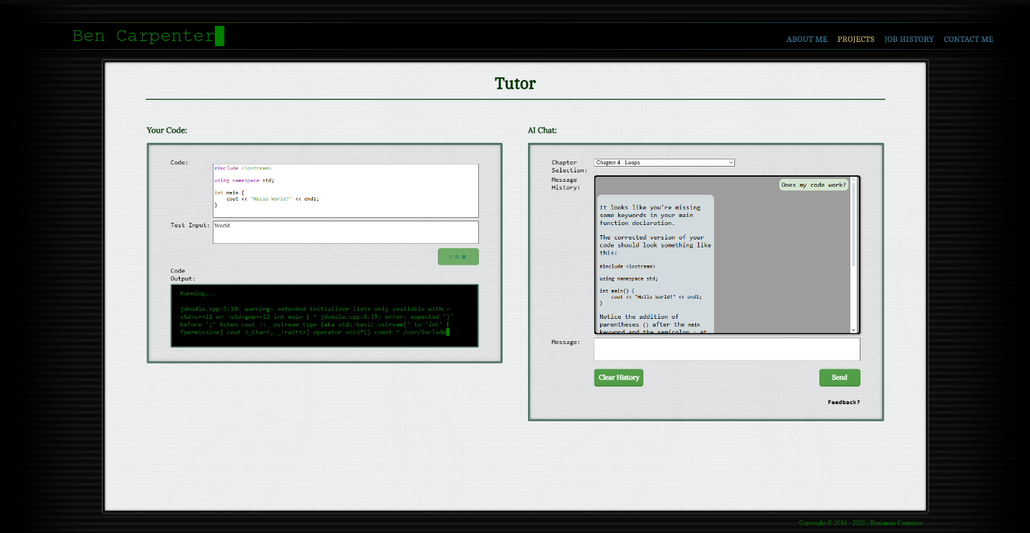

***Figure 1*** – This is an image showing the front-end of our project as we designed it.

For our front-end (see figure 1), we opted for a user-interface built with Hypertext Markup Language, Cascading Style Sheets, and JavaScript. This allows us to build a robust interface that can either be used on a website, or hosted by the local user. We built the frontend with several core features. These include Messaging the AI for help, showing the user’s chat history, remembering inputs from the user’s last session, and chapter selection. Another feature is the running of user-entered code, allowing the testing of your code within the browser.

For the messages, we built a display box that follows similar design language to most cell-phone texting apps. This gives it a feel that will be familiar to a wide range of people. It has a box beneath the display where a question can be typed or a message sent. It also has a button to clear the user’s message history. This is the primary means of interaction with the tutor application.

This chat area not only takes the input, but its core functions include remembering the user’s code, question, and chat history, passing that information to the back-end with every new question. This allows the tutor to have a chain-of-thought, remembering a user’s initial question and responding to normal human language by referencing previously discussed information.

At the top is a drop-down box that allows users to select the chapter of the textbook that they are working in. This not only permits the user to specify a particular section in the course, but it also aids the generation process by limiting the search parameters to the information within that section of the text. By limiting the textual references, the bot is able to work leaner, faster, and more accurately.

To the left of the message area is a code box where C++ code can be entered. Once entered, the front-end will color the code similar to a typical Integrated Development Environment. Doing this provides a familiar experience for people that are used to working in a normal Integrated Development Environment. We were able to achieve this by using a JavaScript library called highlight.js. This library is used to parse the information from the text input field and put it into a colorized and stylized format, displaying it behind that field in real time. The code being edited is actually invisible text inside the text input field overlaying the display element. To further the continuity, we overrode the default tab action to instead place four spaces, similar to Visual Studio Code (A Popular Integrated Development Environment).

Below this we have a user input area. This area is for the commands that a user would typically type into the terminal during the running of the program. We included this because the code is not compiled and run in the browser. (This feature would require web assembly. More about that later). Instead, we decided to use an Application Programming Interface to compile and run the program. 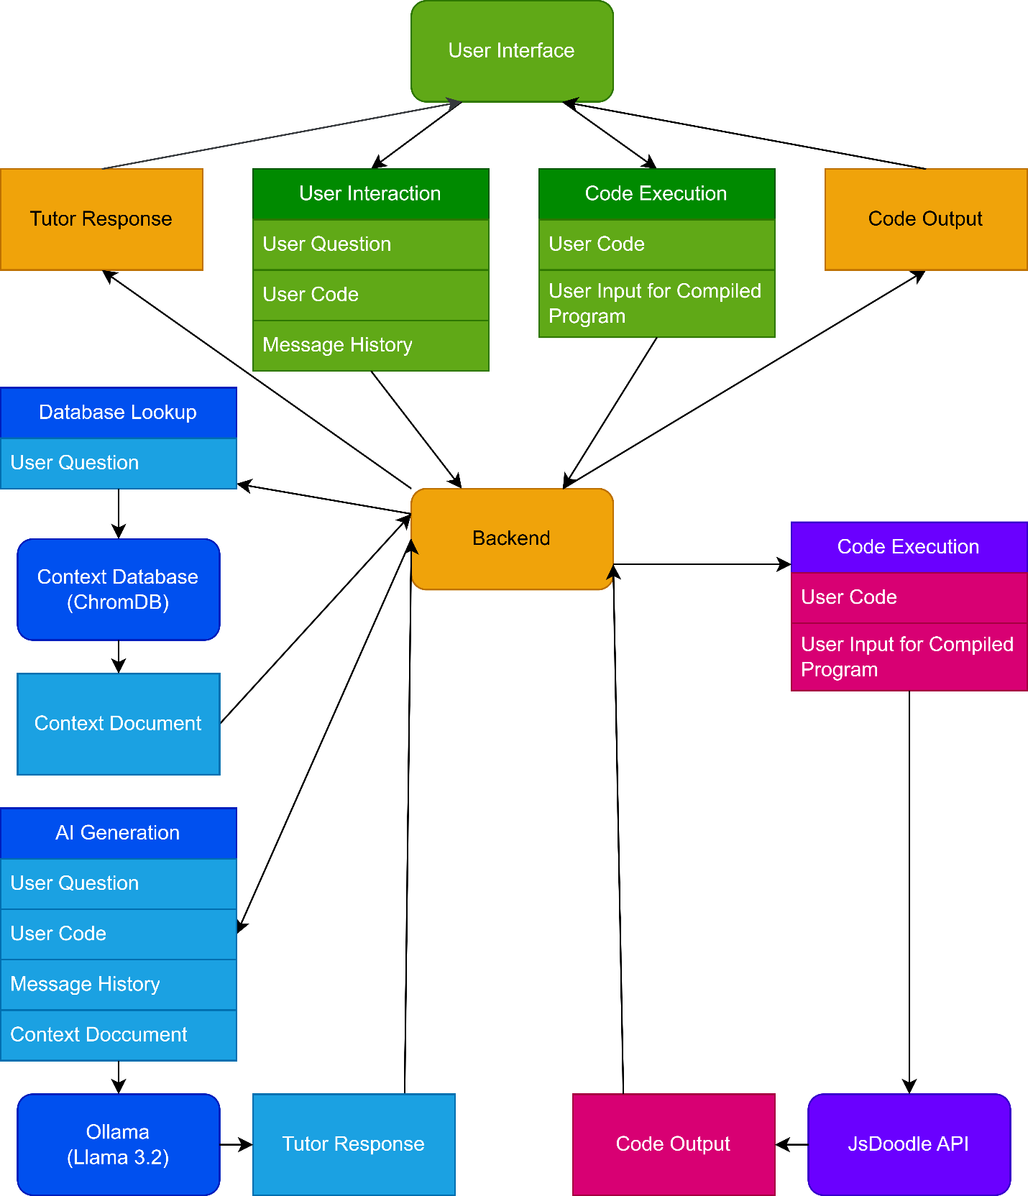

***Figure 2*** – The Chart above show what information is sent where.

Once the user’s question, code, and chat history are submitted, it is sent to the back-end for processing. The back-end was originally designed in C++, but we ran into issues while attempting to implement our vector database library. Due to the time constraints of the project we decided to migrate to Python because of its more robust selection of Artificial Intelligence libraries.

The back-end has three main components. The first handles the loading of all context information into the database, the second processes the user's questions, and the third is responsible for compiling and running the user’s code. The overview of how all the data is processed is in Figure 2.

The context data is all stored in text documents. These are placed in folders according to chapter. When initially started, the back-end gathers the data and is set to Ollama. Running Llama 3.2, Ollama then processes for processing into embeds (can probably grab a reference and explain what embeds are here). In our case, we used the ZyBooks text, chapters one through six for our context documents. Once it has the embeds, the back-end stores them, along with their corresponding context documents and titles, in a ChromaDB database. We chose ChromaDB due to its high functionality and ease of integration into python. The next step for the back-end is to start the Flask server (a webserver library for python) and start listening for questions from the front-end. Once all of this is complete, the back-end is ready to answer questions.

When the question is received from the front-end, it is packaged with extra information. Amongst other items, this extra information includes the chat history, user’s code, and chapter. The first task for the backend is to separate out the information. The app parses the text information into JSON, slicing it into individual elements. It achieves this by using the native JSON parsing tools in python. The user’s question is then processed into an embed. This is then used to search the ChromaDB database. Once ChromaDB returns a document, the generation process can begin.

The generation passes several bits of preliminary information to Ollama, running the Llama 3.2 model. We use the LangChain library to accomplish this, simplifying the formatting of the requests to Ollama. The app first passes the following prompt as a system message “You are a Tutor for CSC108 - Intro to C++. You are answering questions about C++ coding. Use the following pieces of context. to answer the question at the end. If there are No relevant documents found, ask for clarification instead of answering. If you don't know the answer, just say that you don't know, don't try to make up an answer. If it is a vague question, ask for more information. Whenever possible use the Socratic method.” The app then passes the context document as a system message. At this point, it passes the chat history, originally received from the front end. With all the preliminary information sent, it is time to begin the generation by passing the user’s question.

Once the generation is done, Ollama returns the response to our back-end. The back-end then adds the document name to the end as a source (chapter and section). This informs the student where look in the textbook for further information regarding this topic. This process facilitates accurate and sourced answers, to better help the student. The completed message is then sent back to the front-end, which displays it to the user, completing the cycle/process/function…

The final part/function of the back-end is to hands?? processing the user’s code and return the results. This is achieved by, once again, parsing the JSON information sent by the front end and sending a request to the JDoodle Application Programming Interface, containing the user’s code and desired program input. Once our back-end receives a response, it sends that information to the front-end to be displayed to the user. (WORK INTO PREVIOUS PARAGRAPH?)

ChromaDB efficiently identifies and retrieves the most relevant chunks to the query. This combination is what creates the accuracy and contextual precision of/to the? text needed to help the student. This remedies the typical downfall of generative AI simply generating an answer from metadata without concise context. Again, the retrieval process builds the foundation for an optimal educational experience for the student. In this way, it is able to create a user-friendly environment for beginners.

Thus, avoiding hallucinations. Also, system prompts allow it to be guided against responding with hallucinations if the model doesn’t know the answer or doesn’t have enough information. This is an important part of the process as well.

*(beginning of the section about the modularity of the backend)*

Also, one of our goals (*needs to be added to abstract?)* was to create a tutor app that could facilitate other courses and subjects for future work. Our goal was to have an interchangeable backend that can be integrated easily with other subject matter, if that subject matter data is in .txt format. Basically, we can use the RAG tutor for any subject or course and still maintain consistent, efficient experience for the students.

The main components of our backend operate independently of the C++ material so that we can use it for other subjects quickly and efficiently. Our RAG pipeline uses LangChain for text processing, langchain_ollama for generating semantic embeddings, and ChromaDB for vector-based storage. The combination of these tools creates a formidable RAG pipeline that is totally flexible in the subjects it can cover and be used as a tutor. Instead of embedding specific rules for C++ education, the backend will use any .txt material that a tutor or instructor provides the system. The texts are divided into chunks, each chunk is transformed into an embedding vector that represents its semantic content. These vectors are then stored in ChromaDB, providing efficient retrieval when a student submits a question.

Furthermore, any user can convert course textbooks, lecture notes, or supplementary materials into standardized .txt files. These files should be segmented by chapters or topics/ideas to facilitate contextual chunking. This subdivision is critical because it preserves the proper context and ensures that the retrieved content directly relates to the student’s/user’s query.

Next, using LangChain, the text files are taken in and split into semantically coherent chunks. Langchain_ollama then generates embeddings from these chunks, which are stored along with metadata into ChromaDB. This process requires no adjustments to the backend code, which remains the same regardless of the subject matter.

The next phase includes when a user submits a question, the backend converts the question into an embedding using the same model, ensuring compatibility with the indexed content. A semantic similarity search is executed in ChromaDB, and the most relevant text chunks are retrieved. These retrieved chunks are then augmented with the original question to construct a concise prompt for the LLM. Lastly the LLM generates a response that is concise and relevant to the user’s question.

The backend gets its functionality through a REST API, which makes it simple to be integrated into learning systems such as Canvas or Blackboard. Whether the LS uses a web interface or some other interface, the API endpoints take care of queries and responses without any further changes required from the LS. The modularity ensures that teachers, professors, and tutors can employ the backend easily regardless of the learning system.

**Furthermore, this modularity offers significant advantages in terms of scalability. Upgrades to the embedding model or improvements in the vector database can be implemented centrally, benefiting all courses that use the system. This ability to serve multiple subjects with the same core engine reduces redundancy and enhances the overall reliability of the tutoring system. (check this paragraph)**

Finally, the flexibility of our backend allows it to be used with other course materials if they are in a structured .txt format. Simple integration is made possible by the REST API and the other interchangeable components. Additions to the tutor app could include more advanced feedback systems for the students, which seems to be a focus of some of the RAG tutor research that I cited earlier in this paper. The more we can measure the performance of the application, then the more we can improve upon its functionality. One of the main ways to do that is to efficiently get detailed feedback from the students.

*(beginning of carbon efficiency & privacy benefits of local LLM)*

As LLMs power more educational applications their environmental impact has come under examination. Cloud providers commonly allocate multiple GPUs to satisfy service-level objectives for latency and throughput. However, for typical tutoring workloads which consist of short prompts this strategy can backfire. This approach substantially increases carbon emissions.

The LLMCO2 model quantifies this effect. Figure 11 in LLMCO2 demonstrates that, for a Bloom-7b1 inference with a 64-token prompt and batch size of 1, adding GPUs actually raises total carbon footprint. The all-reduce communication required for tensor parallelism across multiple devices introduces latency and extra energy use, outweighing any per-GPU efficiency gains(Zhenxiao Fu). Indeed, although larger batches (e.g., batch size 4 with 1K tokens) can benefit from two or four GPUs by spreading computation, small-scale queries common in interactive tutoring see per-GPU carbon overhead climb steeply as device count increases.

In contrast, hosting the LLM locally on a single GPU avoids these cross-device costs entirely. Without networked communication between GPUs, inference remains streamlined: the model loads once, processes the prompt, and returns a response, minimizing idle cycles and interconnect traffic. This configuration aligns directly with instructional use cases, where students issue brief, focused questions rather than large batch inference jobs.

Furthermore, SPROUT’s “generation directives” approach demonstrates that local inference can cut carbon emissions even more—by over 40%—by controlling output verbosity based on regional grid carbon intensity and prompt requirements. (Baolin Li) Together, these findings indicate that for scenario-specific workloads like a tutoring assistant, a self-hosted LLM on a single GPU not only preserves data privacy but also achieves substantially lower per-inference carbon emissions than default cloud deployments. Educators and institutions aiming for sustainable AI should therefore consider local hosting of appropriately sized models as a greener alternative to multi-GPU cloud inference.

*“The performance benefits of cloud based LLMs may come at a cost of privacy. Privacy risks in LLMs arise from their inherent capacity to process and generate text based on extensive and diverse training datasets. These models, like GPT-3, may inadvertently capture and reproduce sensitive information that exists in training data, potentially posing privacy concerns during the text generation process. Issues such as unintentional data memorization, data leakage, and the potential disclosure of confidential information or PII are key challenges.” (Das)*

In a setting like our tutoring app, utilizing a local LLM basically restricts any outside access to the sensitive data of the user. It also prevents malicious code being supplied to the users query thus preventing various types of software and hardware attacks.

*(Beginning of future research section)*

Throughout our project we ran into several things that would be good extensions of our project, but were out of scope due to time constraints. We would like to include more context from the code by creating a web assembly and live terminal for running the code, that way we can collect a log of the run program as context. This would also allow us to see the errors directly, making troubleshooting code with the tutor easier and more accurate.

Since web assembly is essentially compiling code into an executable for a browser, you would need to take the source code for a C++ compiler, G++ for example, and compile it with a web assembly compiler. Once you did that you would have to figure out how to take the code, save it as a file in the web assembly file structure, compile it using the compiler, and then finally run it, while being able to access its input and output live. This would likely mean you needed to also compile a terminal application in web assembly.

Another area of possible research would be to use CORAG instead of RAG, allowing for multiple context searches instead of one. This would allow things like the C++ online refrence to be used in addition to the textbook, as well as other sources. This would make the tutor even more accurate than it is currently.

More work into making it more Socratic.

More testing with different models would be a good area of reserch as well. Since we only used Llama 3.2 testing to see if there is a better model for the question answering would be good. Also you could test and see if splitting the embeds into a unique embed focuse model wouuld incresease accuracy.

The cost of premium AI services of outpaces the speed benefits. We found Llama to be an excellent when weighing speed, flexibility, and cost.

**MY OUTLINE**

Approach

Why choices (RAG, LLM, OLlama, Llama)

The advantage of our app is that it is set up to be able to use any model avalible for Ollama. THis means that you can use a bunch of different models, and with the Results-Agumented Generation, increase their accuracy. This allows for you to reach near comercial qualtiy, but at a very reduced cost.

Another study by Wang and Ramon **(Quantitative Evaluation of Using Large Language Models and Retrieval-Augmented Generation in Computer Science Education)** quantified the performance of different AI models and how effective they were by a cost-effective analysis for instructors. "Implementing RAG enhances the ability of LLMs to answer context-specific questions accurately. This improvement is particularly noticeable in models with integrated course materials and pre-answered question databases and allows open-source models to close some of the gap with GPT-4."

Moreover, they found that advanced model Large Language Models did outperform open-source models in Q&A tasks. However, the performance gap wasn’t significant enough to justify the cost-benefit of using locally hosted open-source models. The needs of the instructor/students should be considered in this regard.

Though we took a unique path, a significant inspiration was Ragman

UC-I Study (Ma…)

**PROBLEM WORDS**

Course/class

AI

RAG Man/RagMan

App/Application/Tutor App

Info

Backend/back-end